Prototype Report

<TeaDrinkers>

<John Sun(Product manager)
Kata Ota(UX designer)
Frank Li(Tech Lead)
Eric Vuu(Tester)>

<Date>

Version History
Date |  | Author |  | Version |  | Changes made |  | Rationale
03/14/17 | SK |  | 1.0 |  | - First draft |  | - To fit CS161 content
5/9/17 |  |  |  |  |  | - Final draft |  | - To finish cs161 content

Table of Contents
Prototype Report i
Version History ii
Table of Contents iii
Table of Tables iv
Table of Figures v
1. Introduction 1
1.1 Purpose of the prototype report 1
1.2 Status of the prototype 1
2. Navigation Flow 2
3. Prototype 3

Table of Tables
Table 1: Screenshot name-1 3
Table 2: Volunteer Clock Out Page 4

Table of Figures
Figure 1: Navigation Flow of Volunteer Tracking System 2
Figure 2: screenshot name 1 3
Figure 3: Clock-out page 4

Introduction

- The final iteration of our project we have a complete UI overhaul and a working database that stores players information and a working game lobby that connects all the players to the game

Navigation Flow

Figure 1: Navigation Flow of Volunteer Tracking System
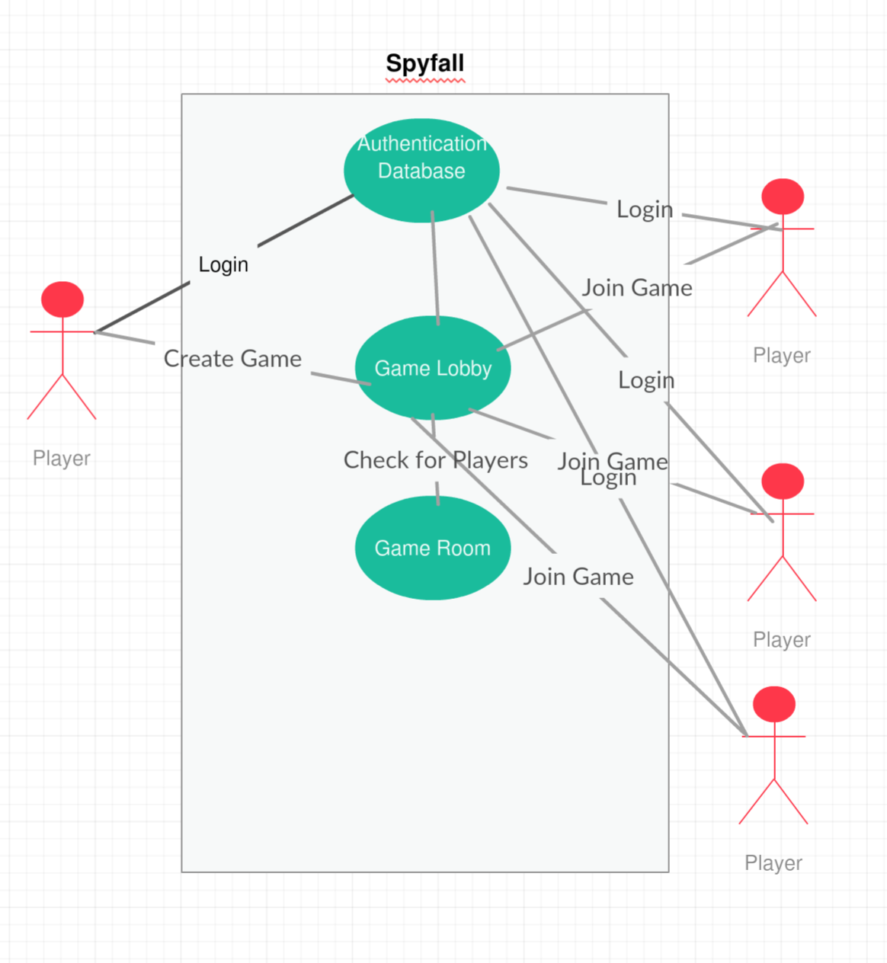

Prototype
<< Most students think about prototype as sample screenshots of system’s graphical user interface (GUI). It is not always true. With the risk-driven approach, you should select the riskiest module or the functionalities that you are uncertain about to develop a prototype. The prototype, especially the initial version, does not have to be in the form of GUI. It could be in the form of algorithm prototyping, interoperability prototyping, performance testing and etc. Again, if you select to prototype on GUI in order to model the story telling, or look and feel, it would be much better NOT to pick the easy one such as login page. >>

<< Use the following table to describe what this screenshot/figure is about, what capability requirement/goal it relates to. >>

Table 1: log in
Description | This is the what you will see at the start of the application to register and log in to the game
Related Capability | To process information to the database and use that information when playing the current game
Pre-condition | App is launched
Post condition | You are in the database

